**LINUX APP SERVER AND WEB SERVER:**

**WEBSERVERS:**

This will help us to manage or deploy the static websites.

For example: if you go to some website like gmail.com or fb.com or Instagram.com etc there will appear a page which is static means stable where everyone gets the same front page of the web.

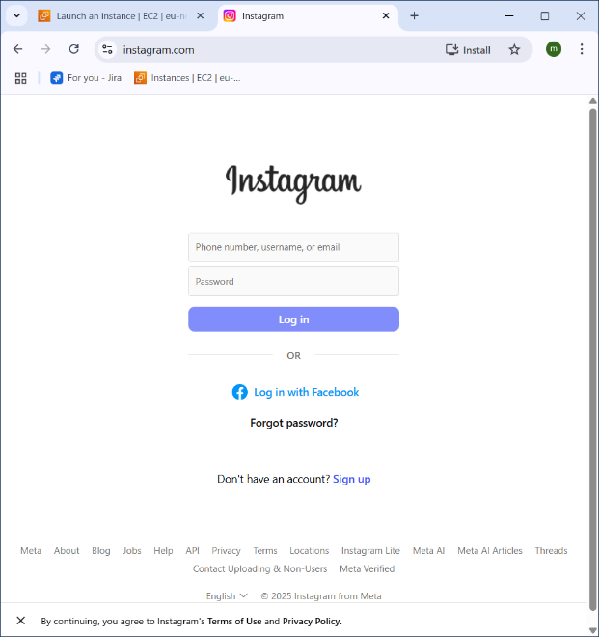

**Type of web servers** :

* Apache (httpd)
* Nginx

Are the two different web servers.

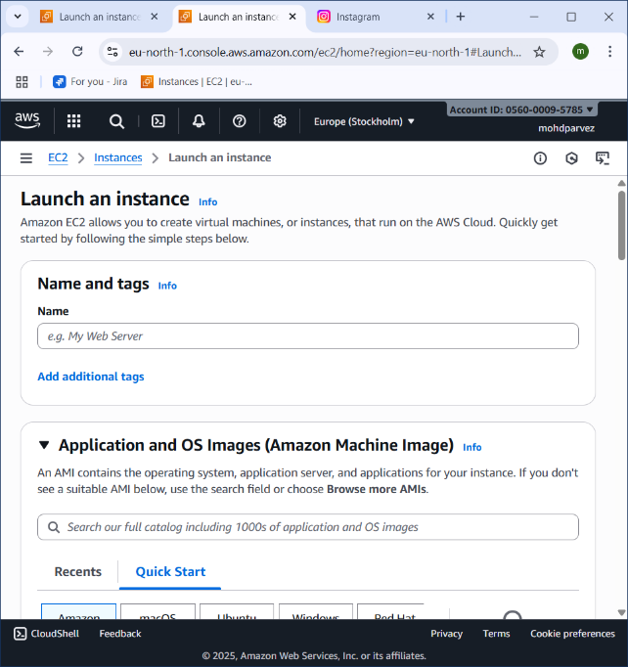**HOW TO CONFIGURE THE WEB SERVERS:**

**Lauch ec2 instance in aws:**

* Go to aws console login in your aws account
* Go to lauch instance
* Give server name as need
* 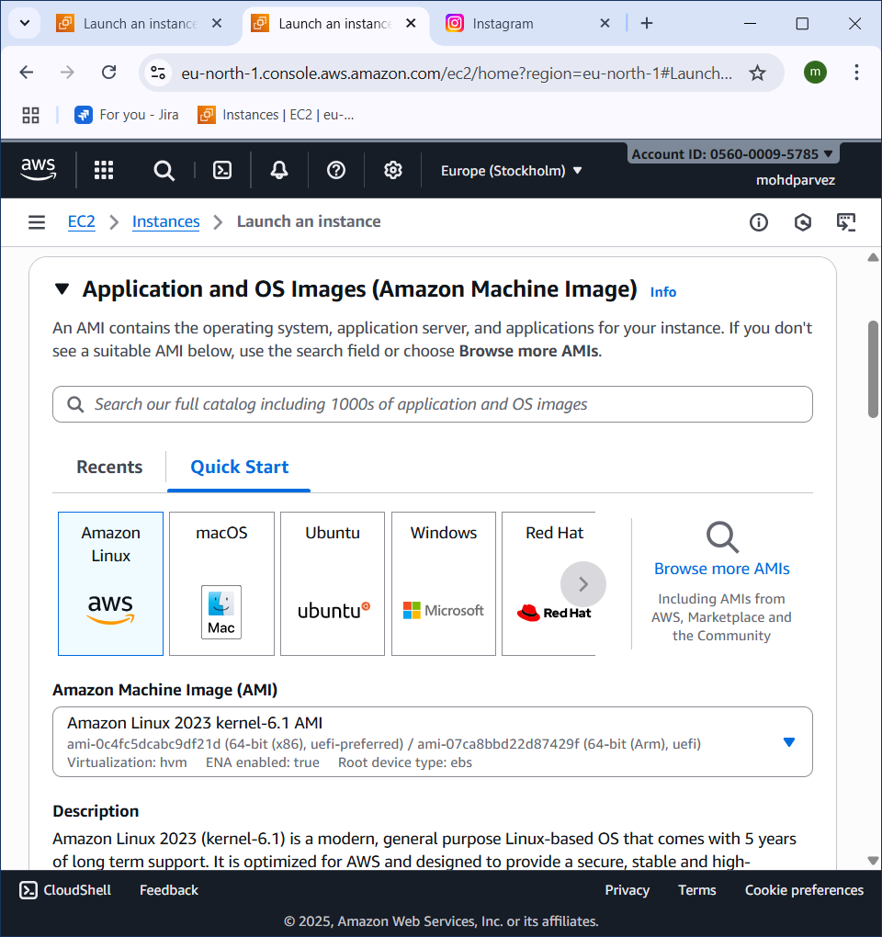select the application image : amazon linux ,ubuntu ,red hat as per use.
* Select the amazon linux machine image (AMI).

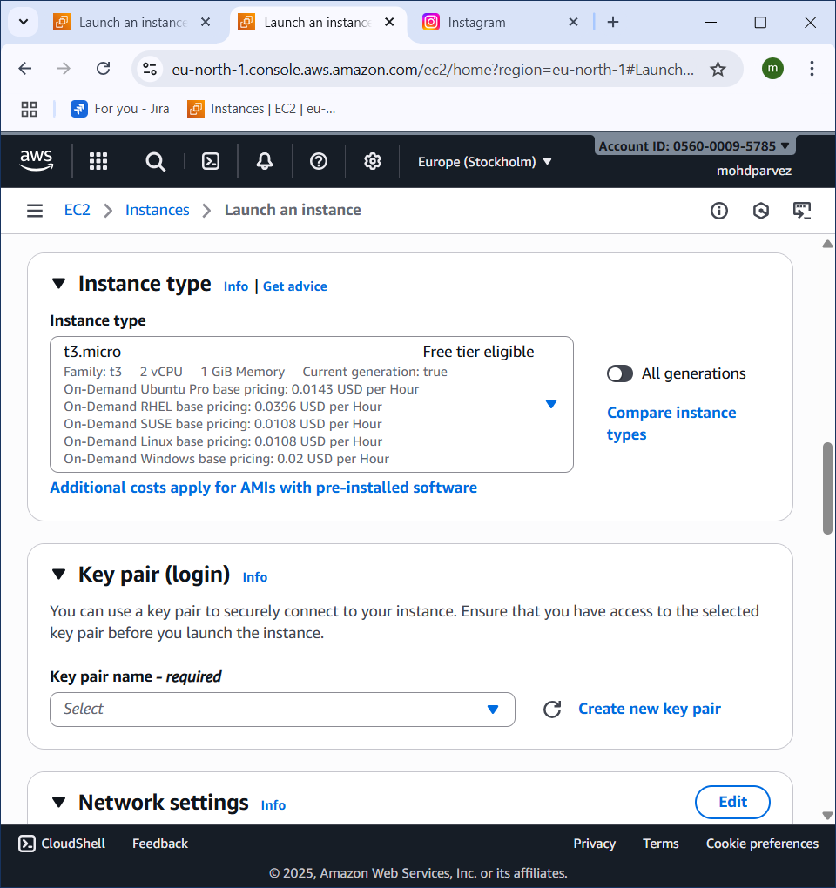

* Select instance type t3.micro or t2.micro.
* Create key pair or use existing keypair.pem.
* 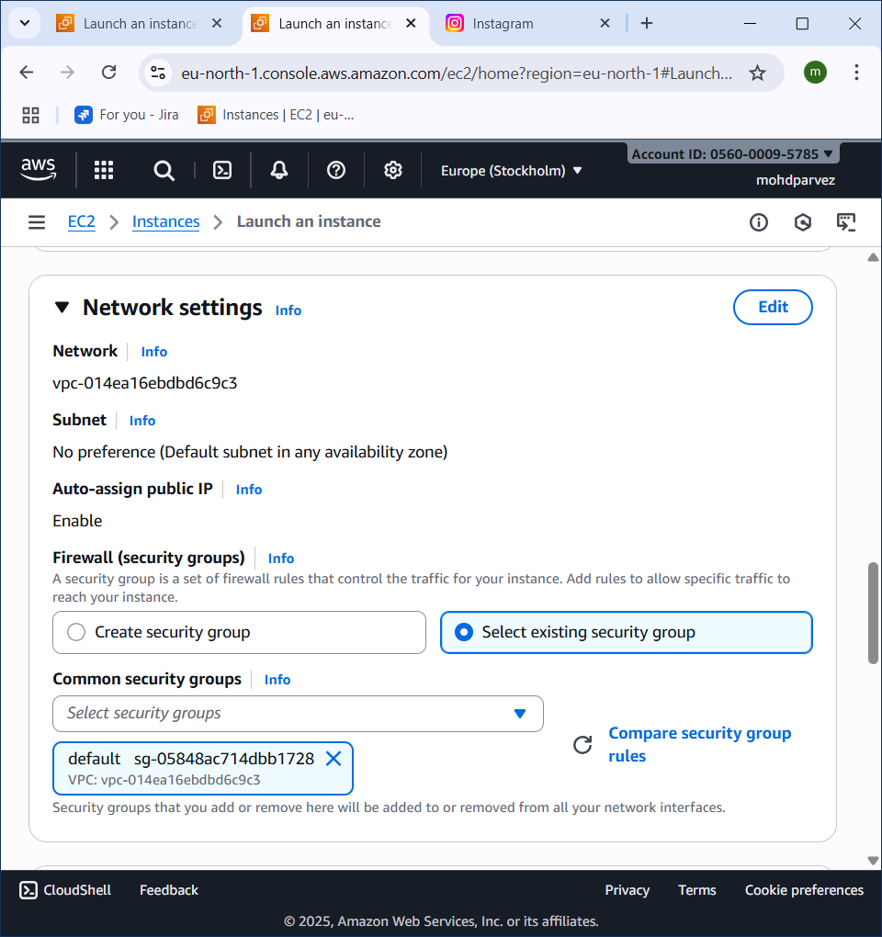in network settings select existing group aand select default or create in user group don’t change anything and allow all tick marks below it.

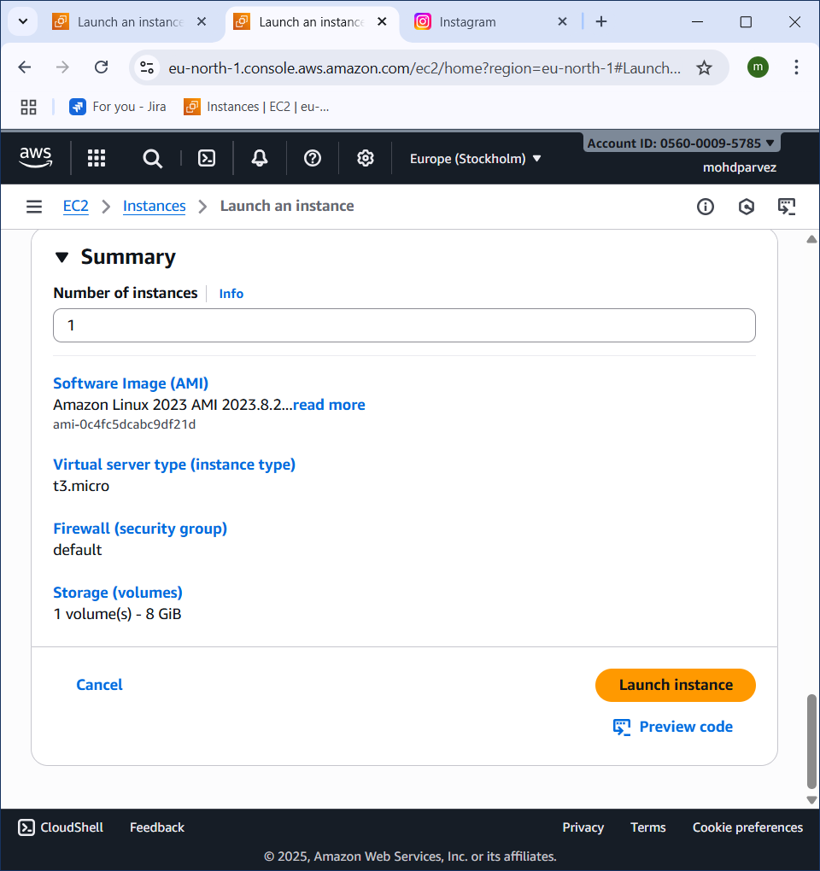

* Then click on lauch instance .
* 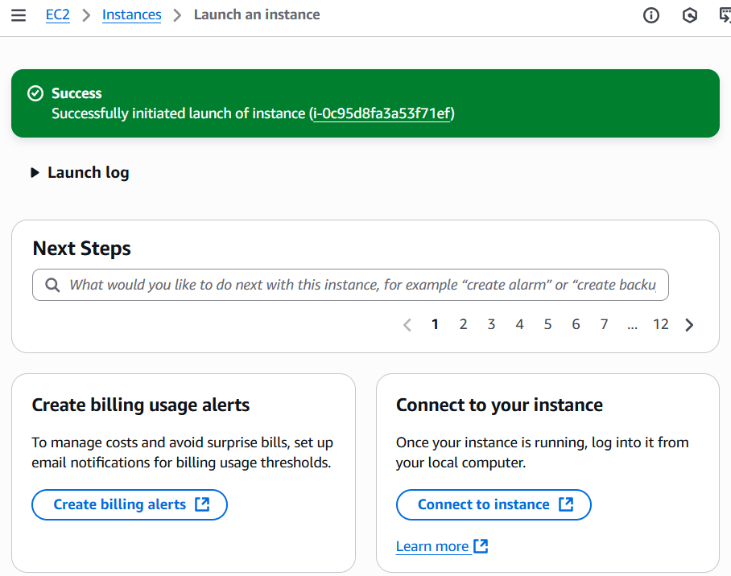the instance is launched.
* 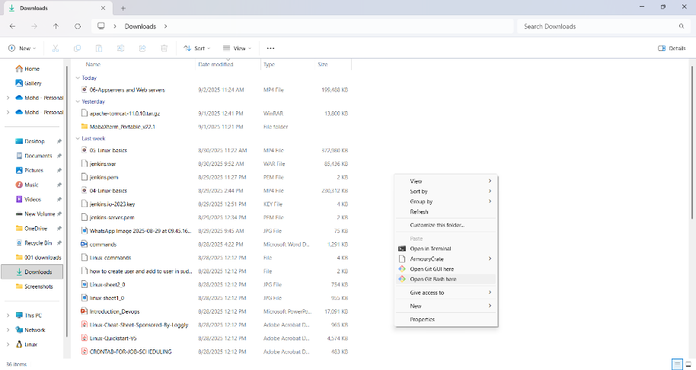Go to the storage where the key pair is downloaded.
* And right click and run select git bash here.

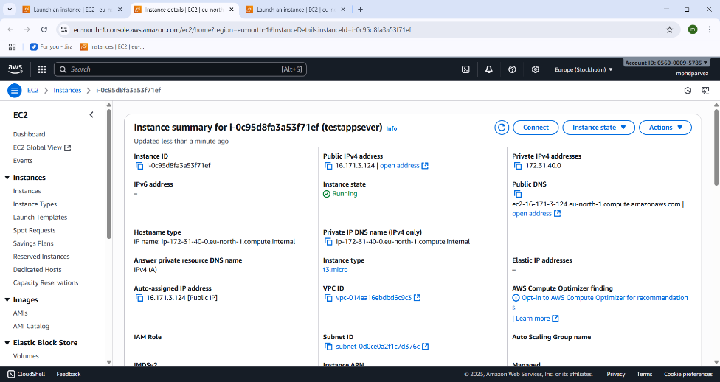

* Copy ip v4 adress from aws ec2 instance

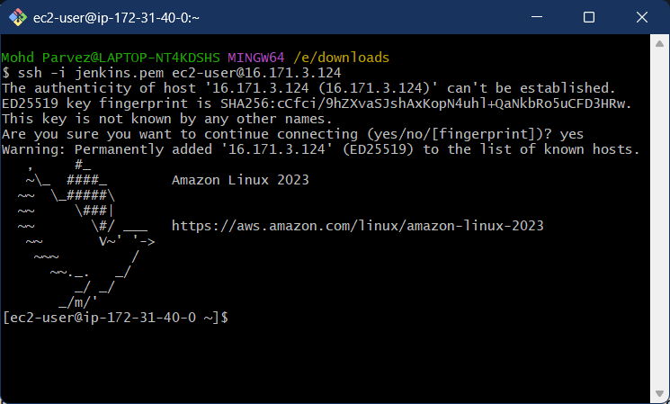 **How to Install and deploy a sample index.html in httpd (apache)**

* Open git bash and run command
* ssh -i “keypairname.pem” ec2-user@public_ip.
* Copy public ip from aws instance.

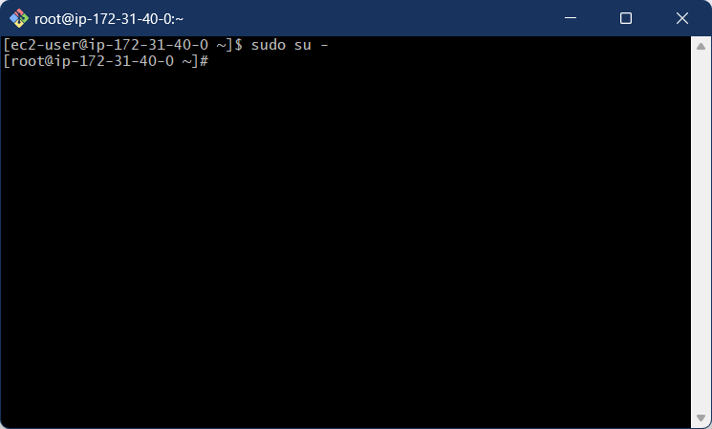

* Switch user to root using
* Sudo su –
* 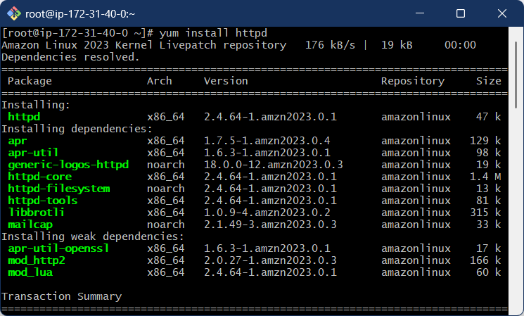To not get any issues regarding
* Enter : yum install httpd
* To install the httpd service.

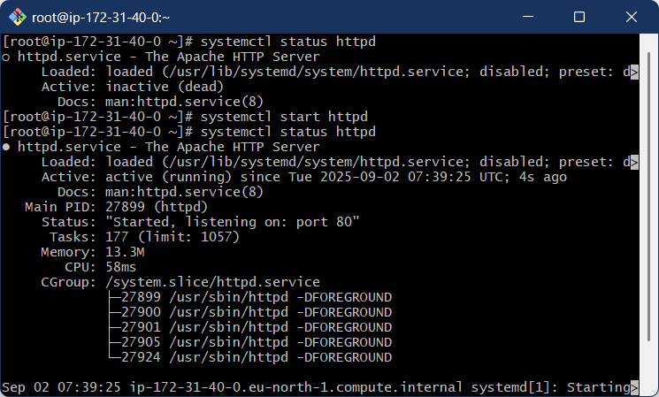

* Enter:

systemctl status htttpd

To check the service status

* Enter :

Systemctl start httpd

To start the service

* 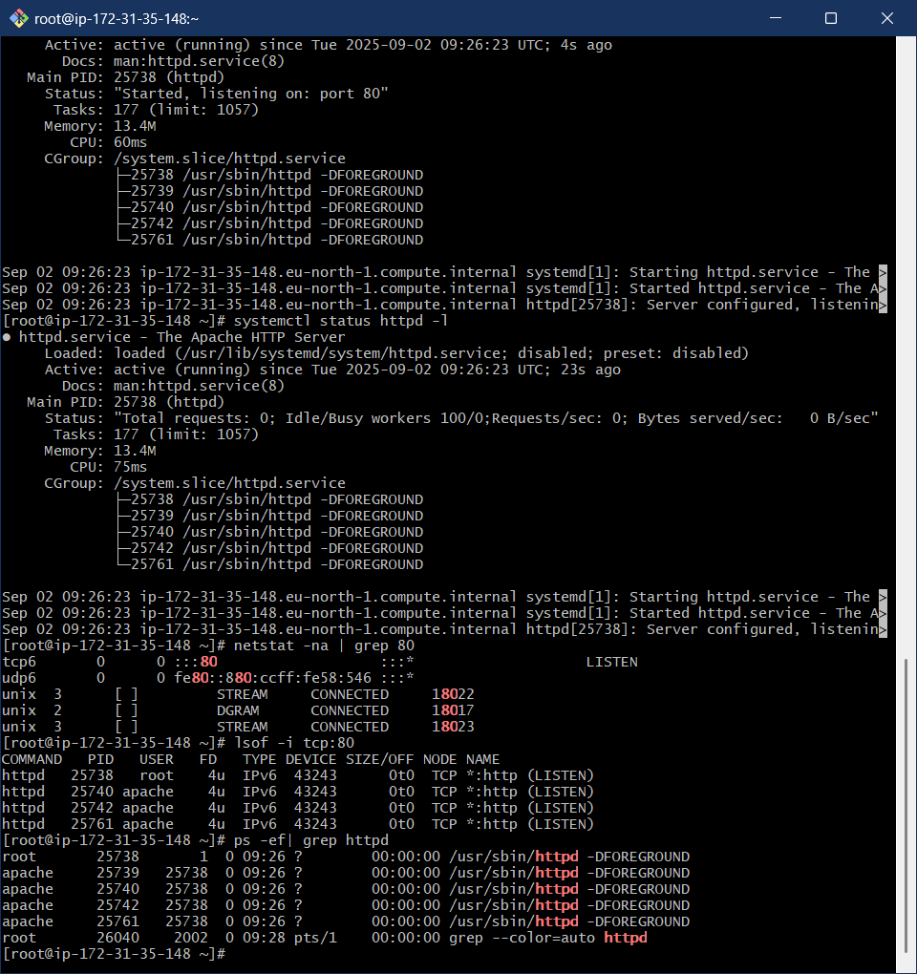netstat -na | grep 80

To know the services running in 80 port.

or

* lsof -i tcp:80
* ps -ef | grep 80 : check specific service running.

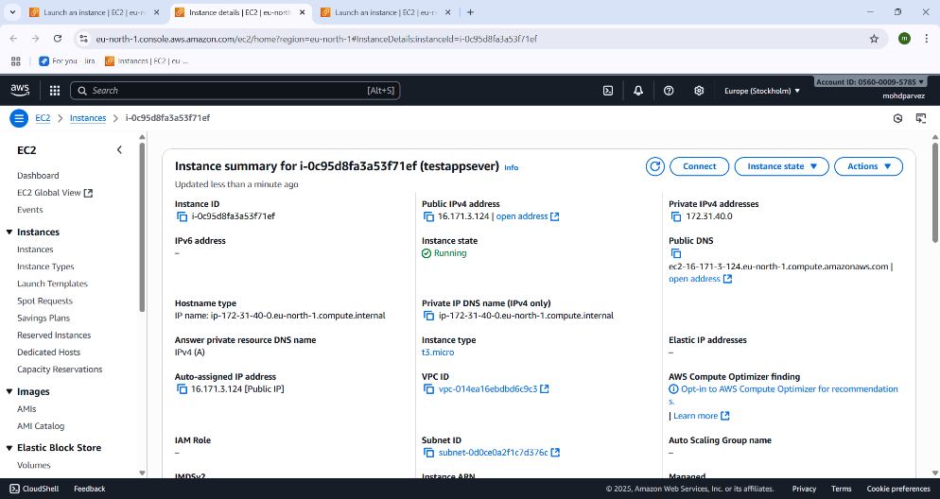

* copy ipv4 adress

i.e 16.171.5.124 from aws instance .

* 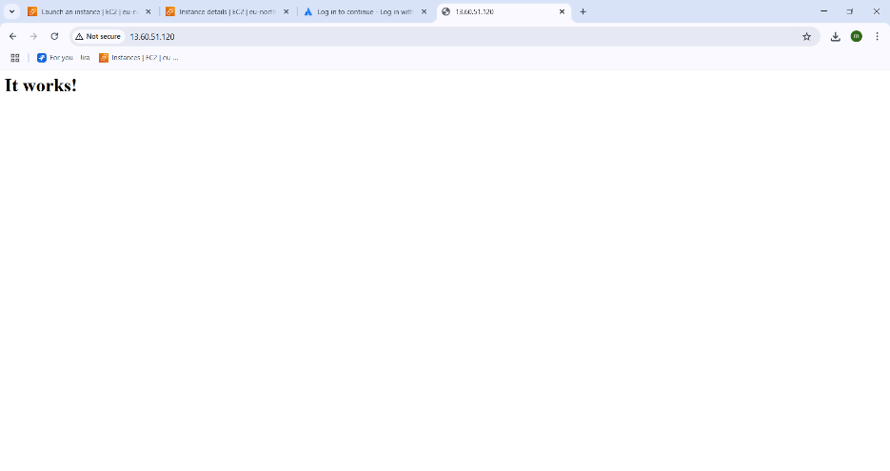go to web browser and paste ip address 80 is the port where the service is
* “ip_ address public”:80
* There you can see the service is running.

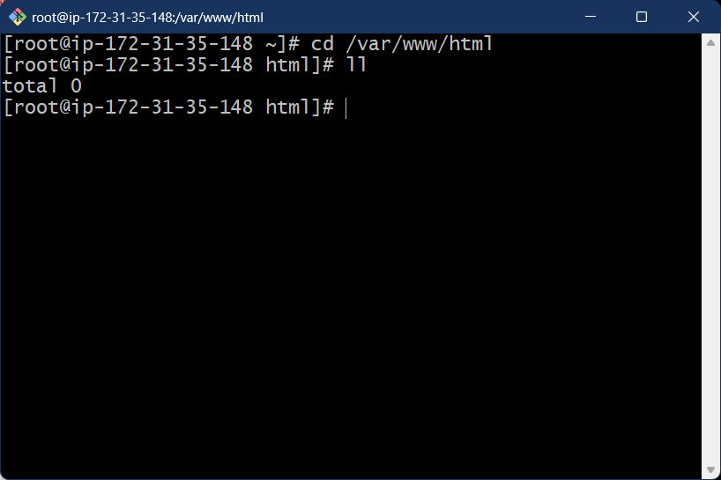**2 .HOW TO DEPLOY THE SMAPLE INDDEX.HTML ON HTTPD**

* Go to html directory:

Cd /var/www/html

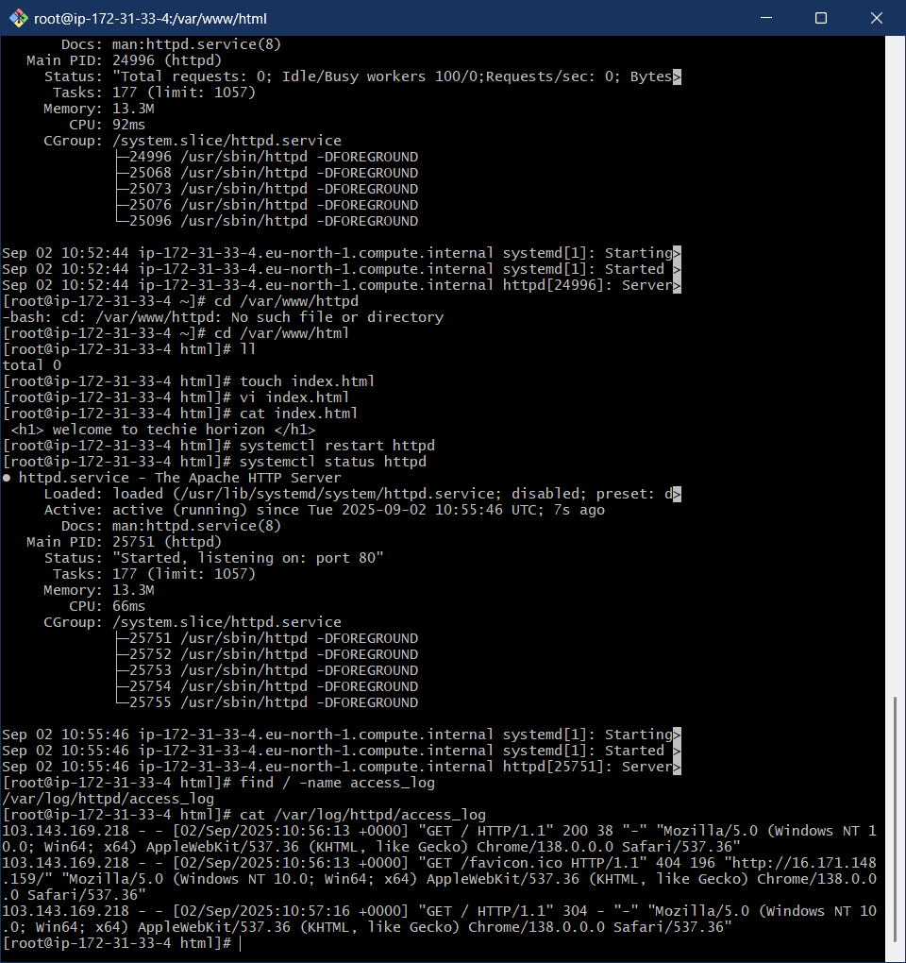

* create a file using

touch: “filename”.html

* Vi “filename”.html
* And enter the <h1>”output you want” </h1>
* Save it by - enter esc then enter- “:wq!” to save and exit the file.
* Then restart the service- “systemctl restart httpd”

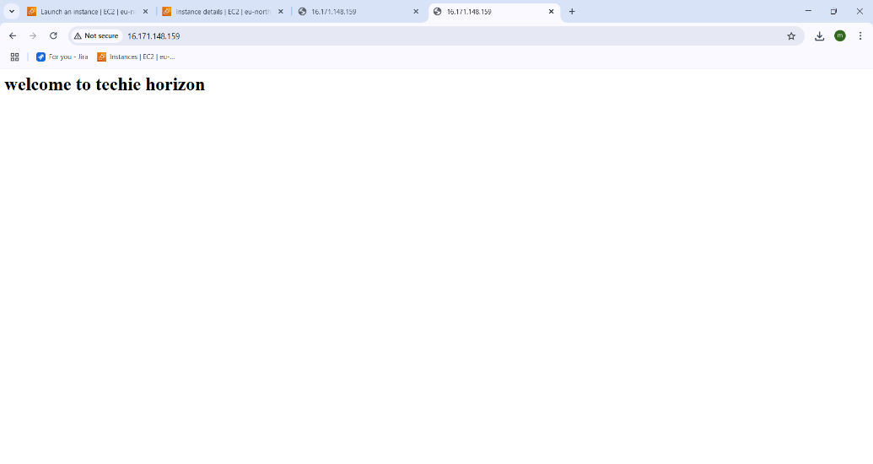

* Now go to web page and enter- “ip address public “:80
* Copy the ip address from aws
* Here you see your static web page output you created on httpd.

1. **INSTALL NGINX AND RUN NGINX ON PORT NUMBER 81**.

* 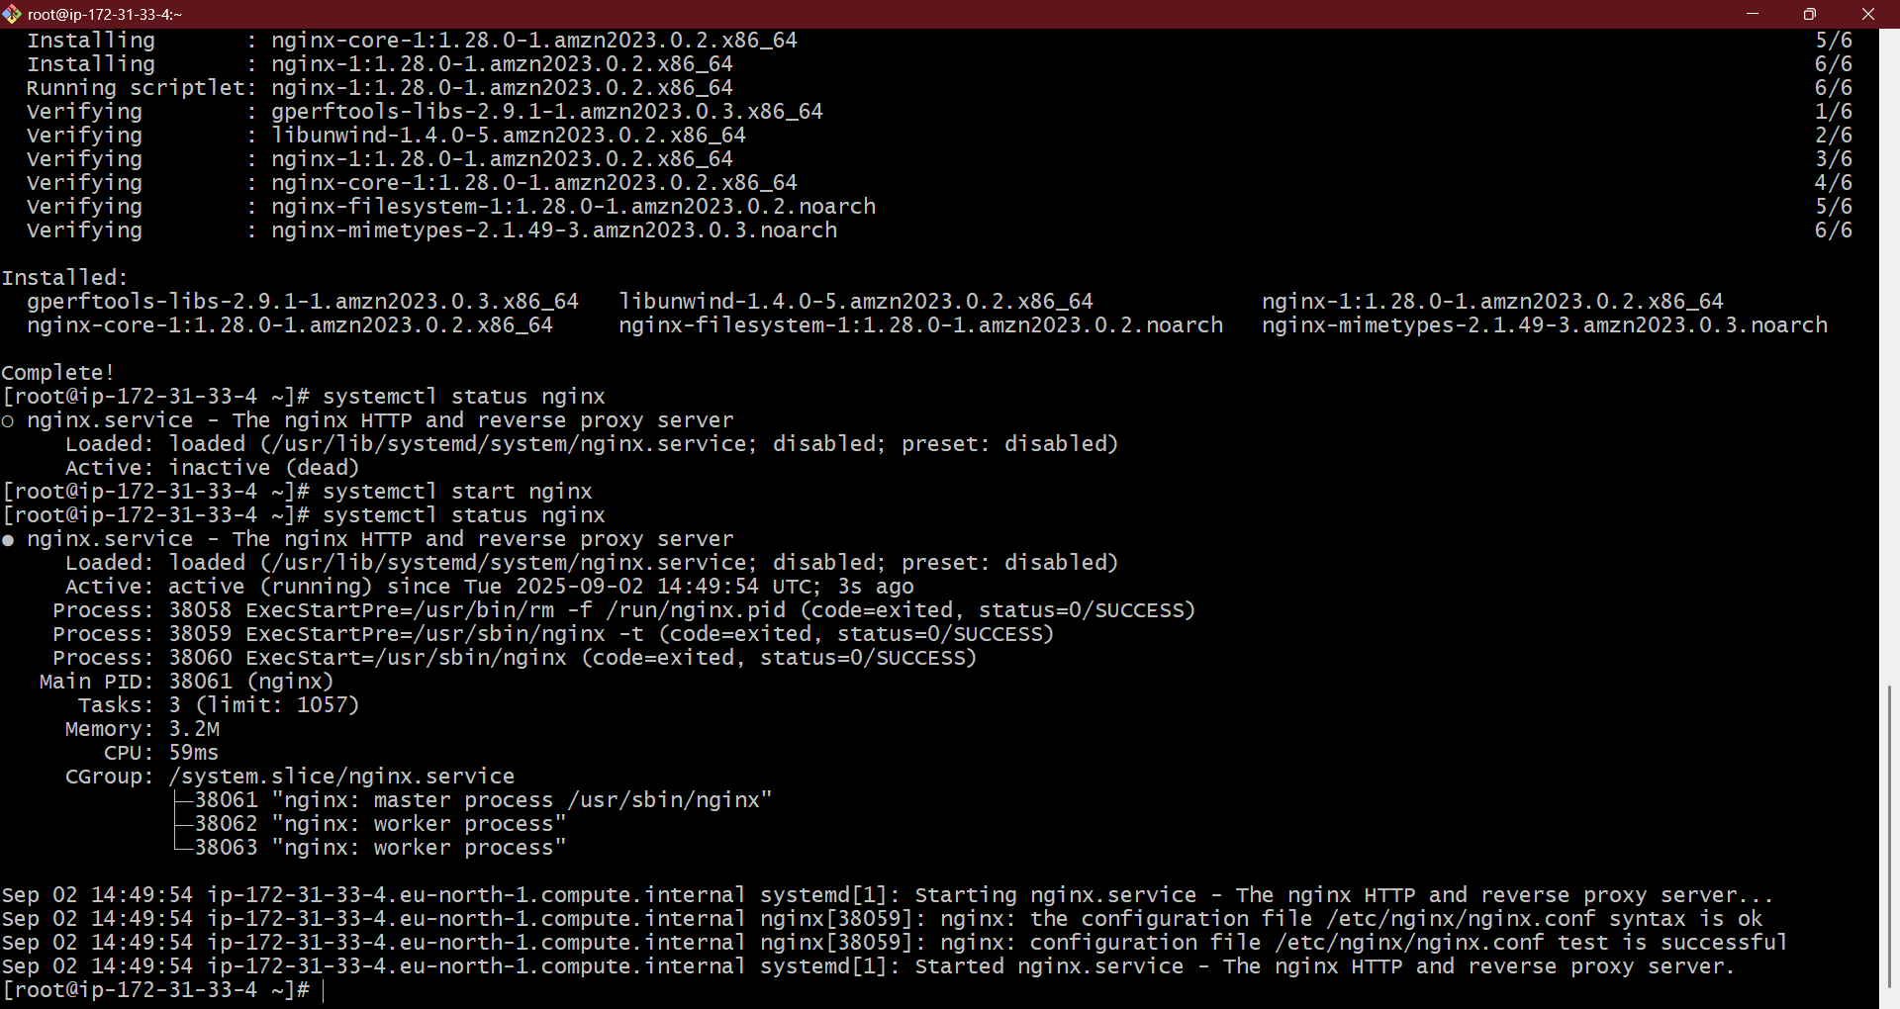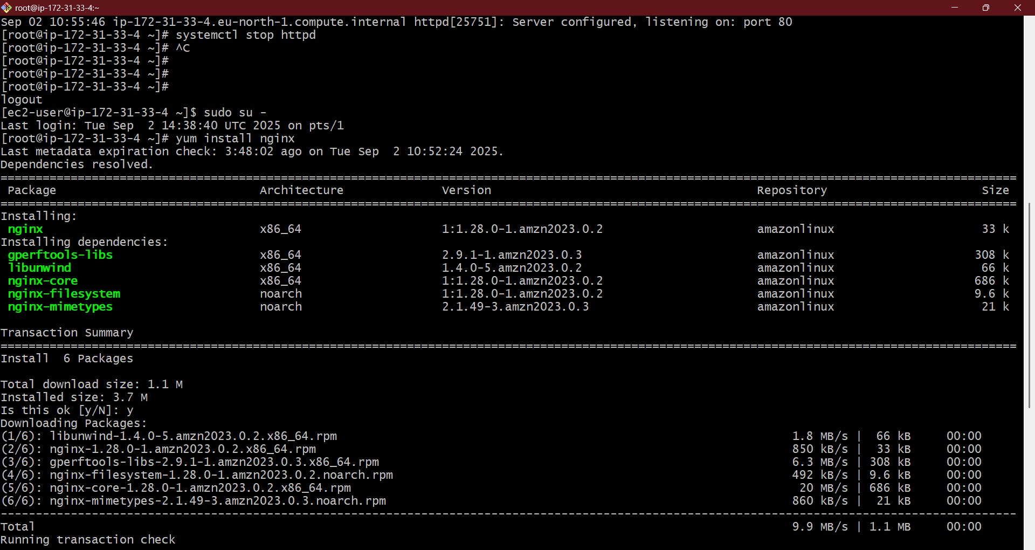install nginx service in linux machine : yum install nginx
* start the nginx service : systemctl start nginx

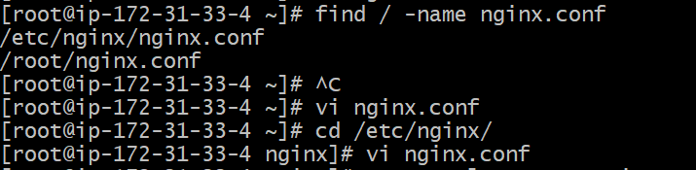

* find the file : file / -name nginx.conf
* go to the directory : cd /etc/nginx/
* view the file contents : vi nginx.conf
* 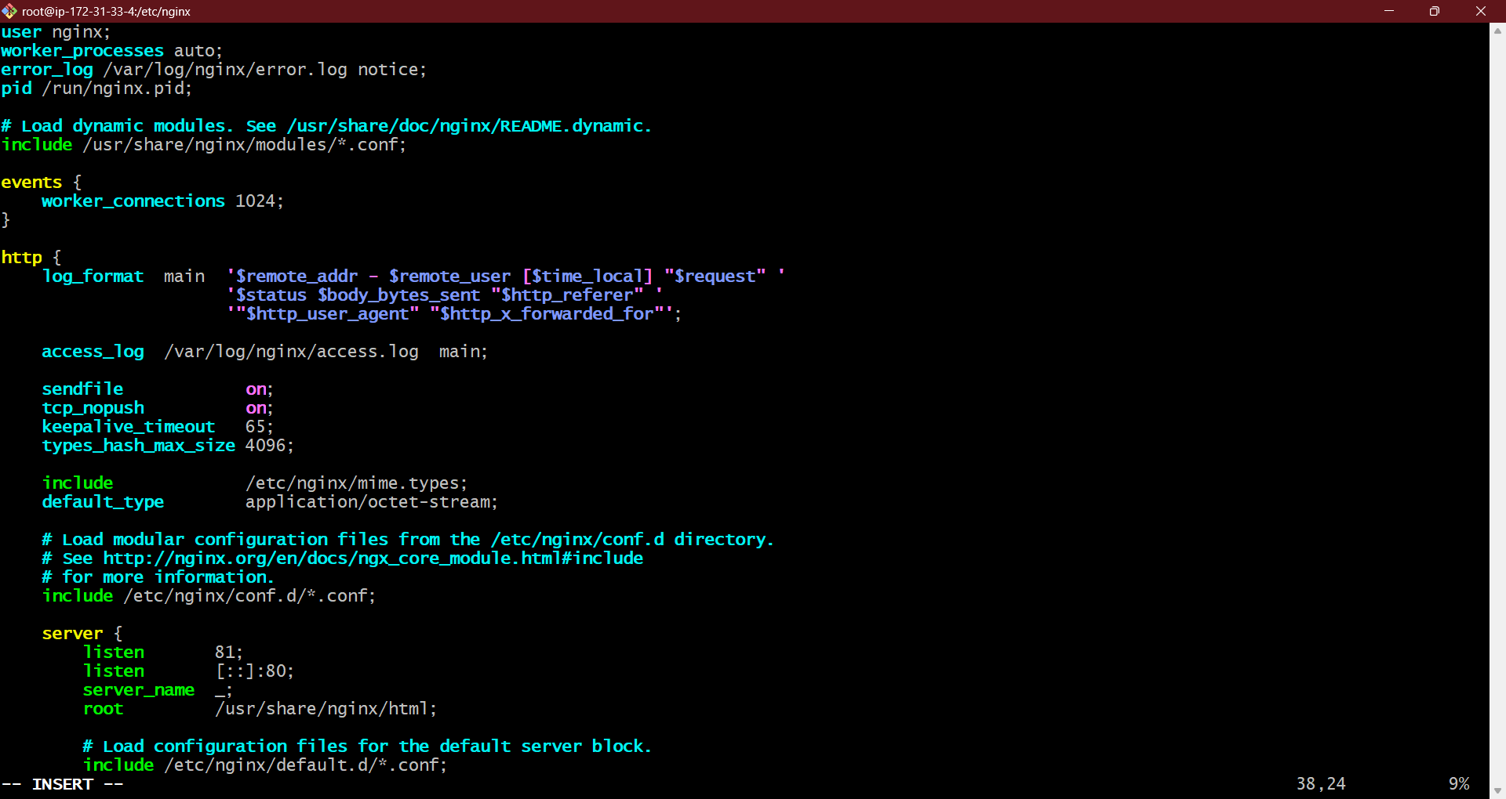in nginx.conf change : LISTEN 80 to 81 by using ‘i’ – insert
* Enter : esc :wq! – to save and exit the file

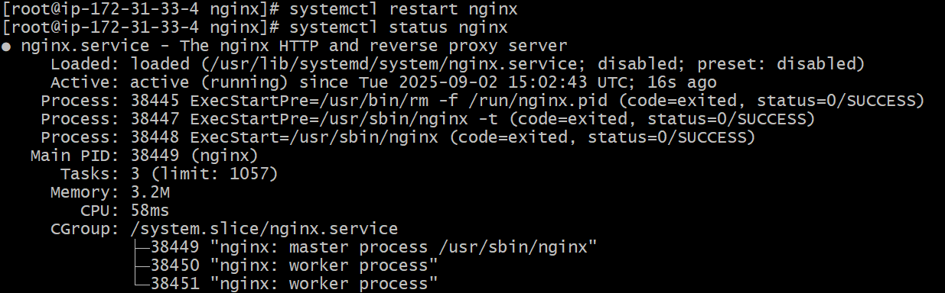

* Restart the service : systemctl restart nginx

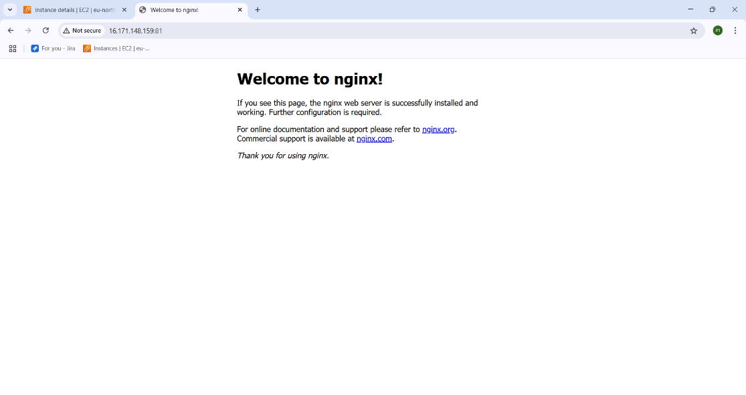

* Now got o web and enter the – “ipv 4 publicadress: 81”
* You can see the nginx is running in port 81.

1. **HOW TO INSTALL AND RUN HTTPD IN PORT 82**

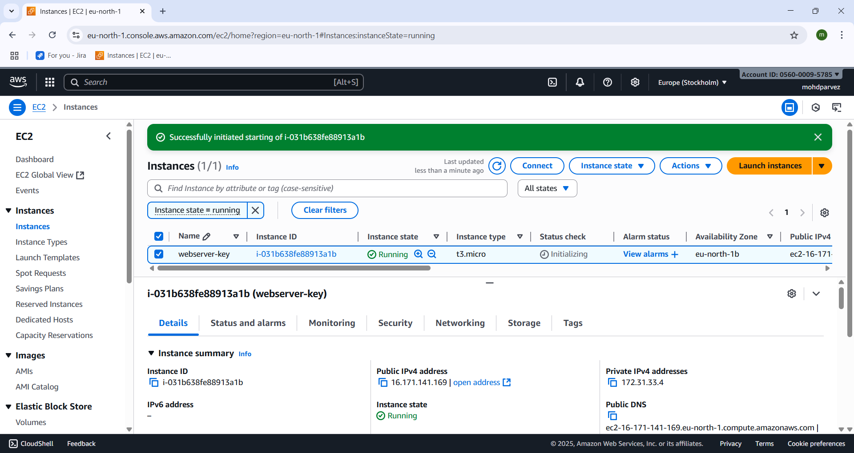

* Lauch aws ec2 instance .

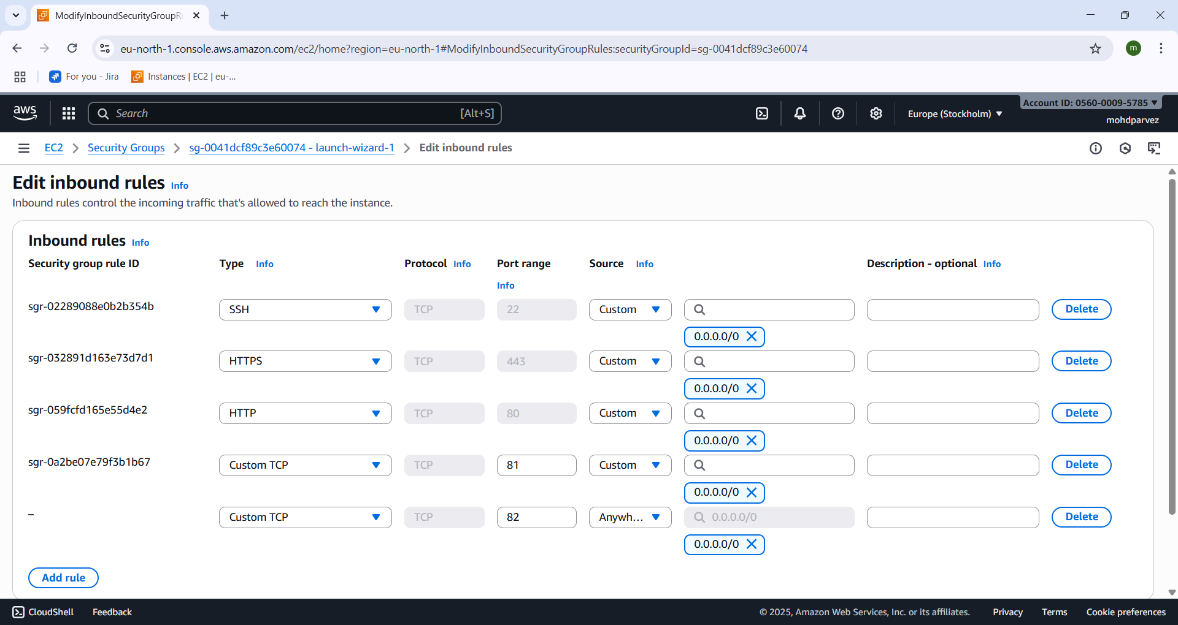

* Go to security groups and click on edit inbound rules
* Add security group with custom tcp and give port no 82 and save.

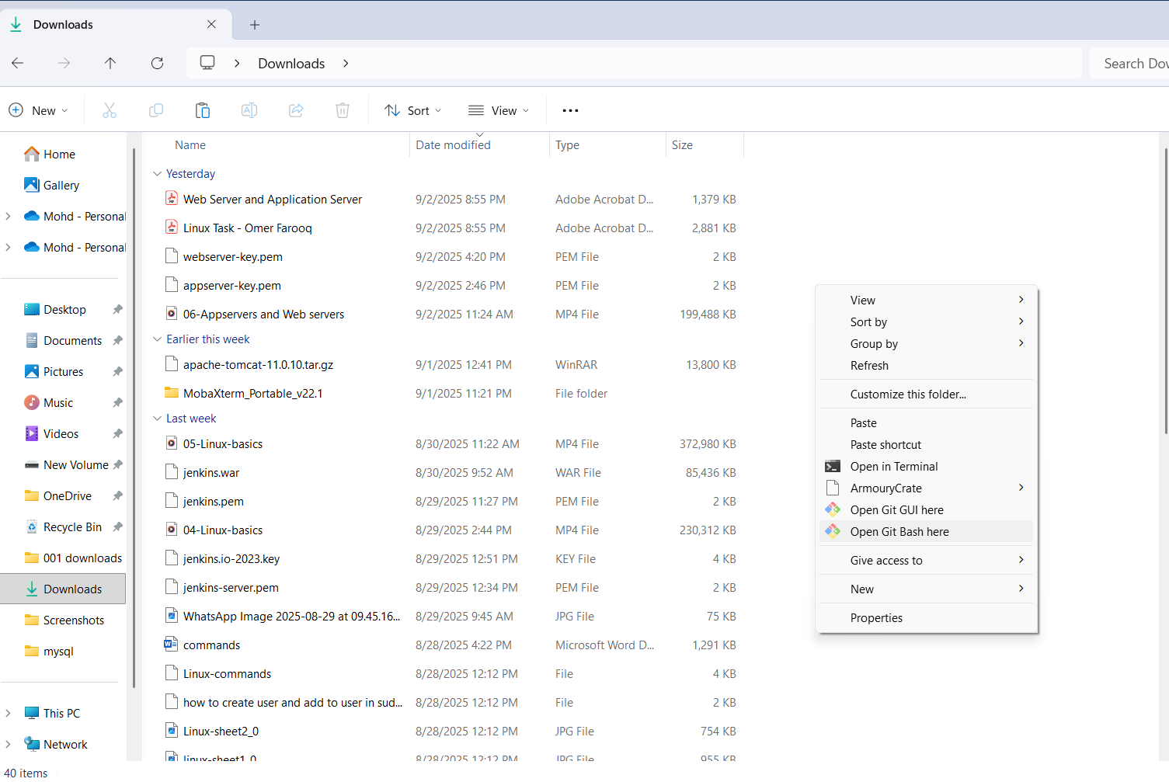

* Go to the location where keypar.pem is downloaded and right click and select open git bash here.

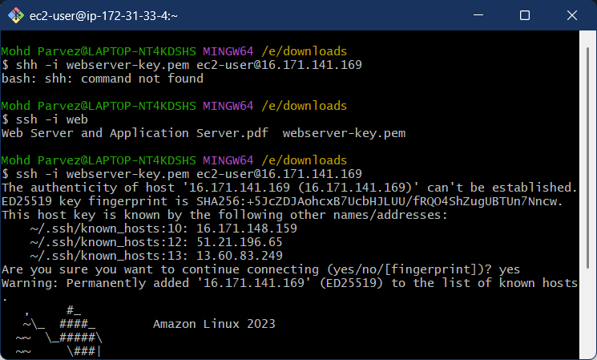

* Connect to the remote machine by using : ssh -i “keypair.pem” ec2-user@ “ip_v4 _public address”.

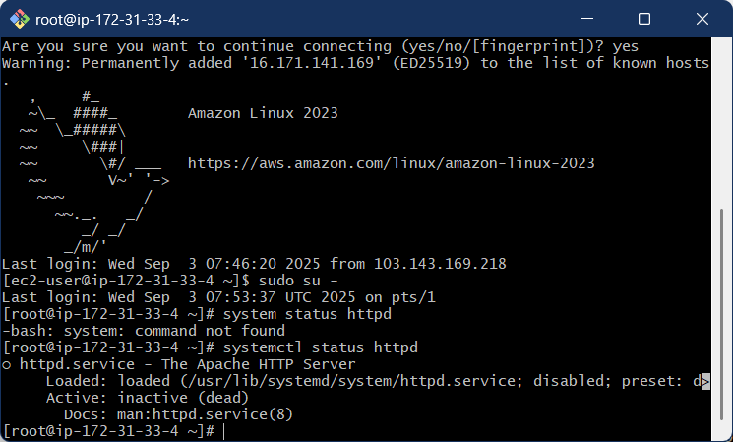

* Install the httpd (apache ) service : yum install httpd
* Check the status of httpd (apache) : systemctl status httpd

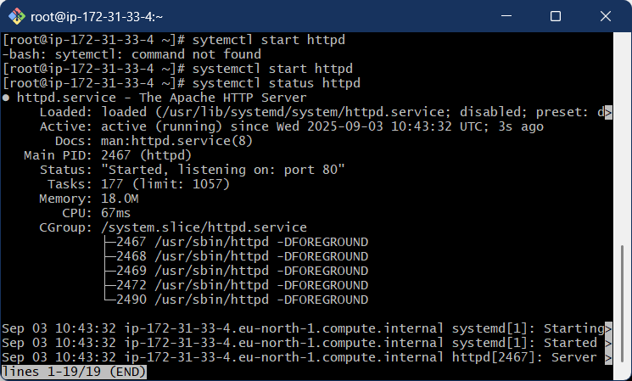

* Start the service if it is inactive : systemctl start httpd

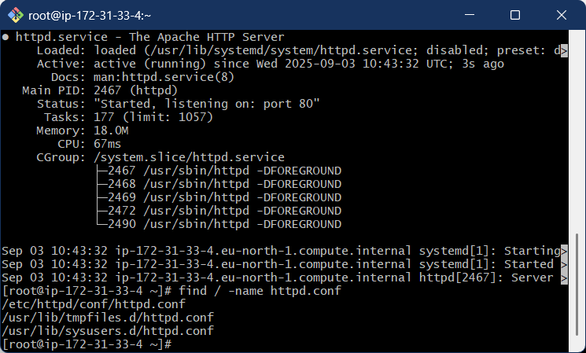

* Find the configuration file using : find / -name httpd.conf
* Go to the directory where the httpd. Conf file is located using cd command

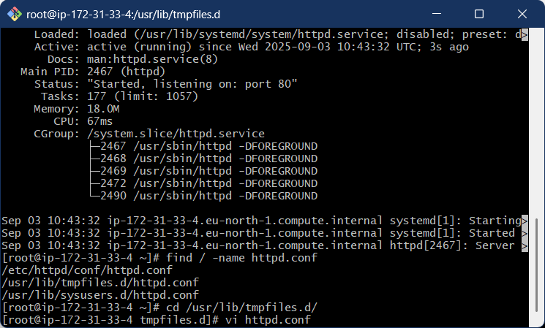

* Cd /usr/lib/tmpfiles.d/ : going ton the directory where the httpd.conf file is present
* See the content in the file : vi “filename”.conf

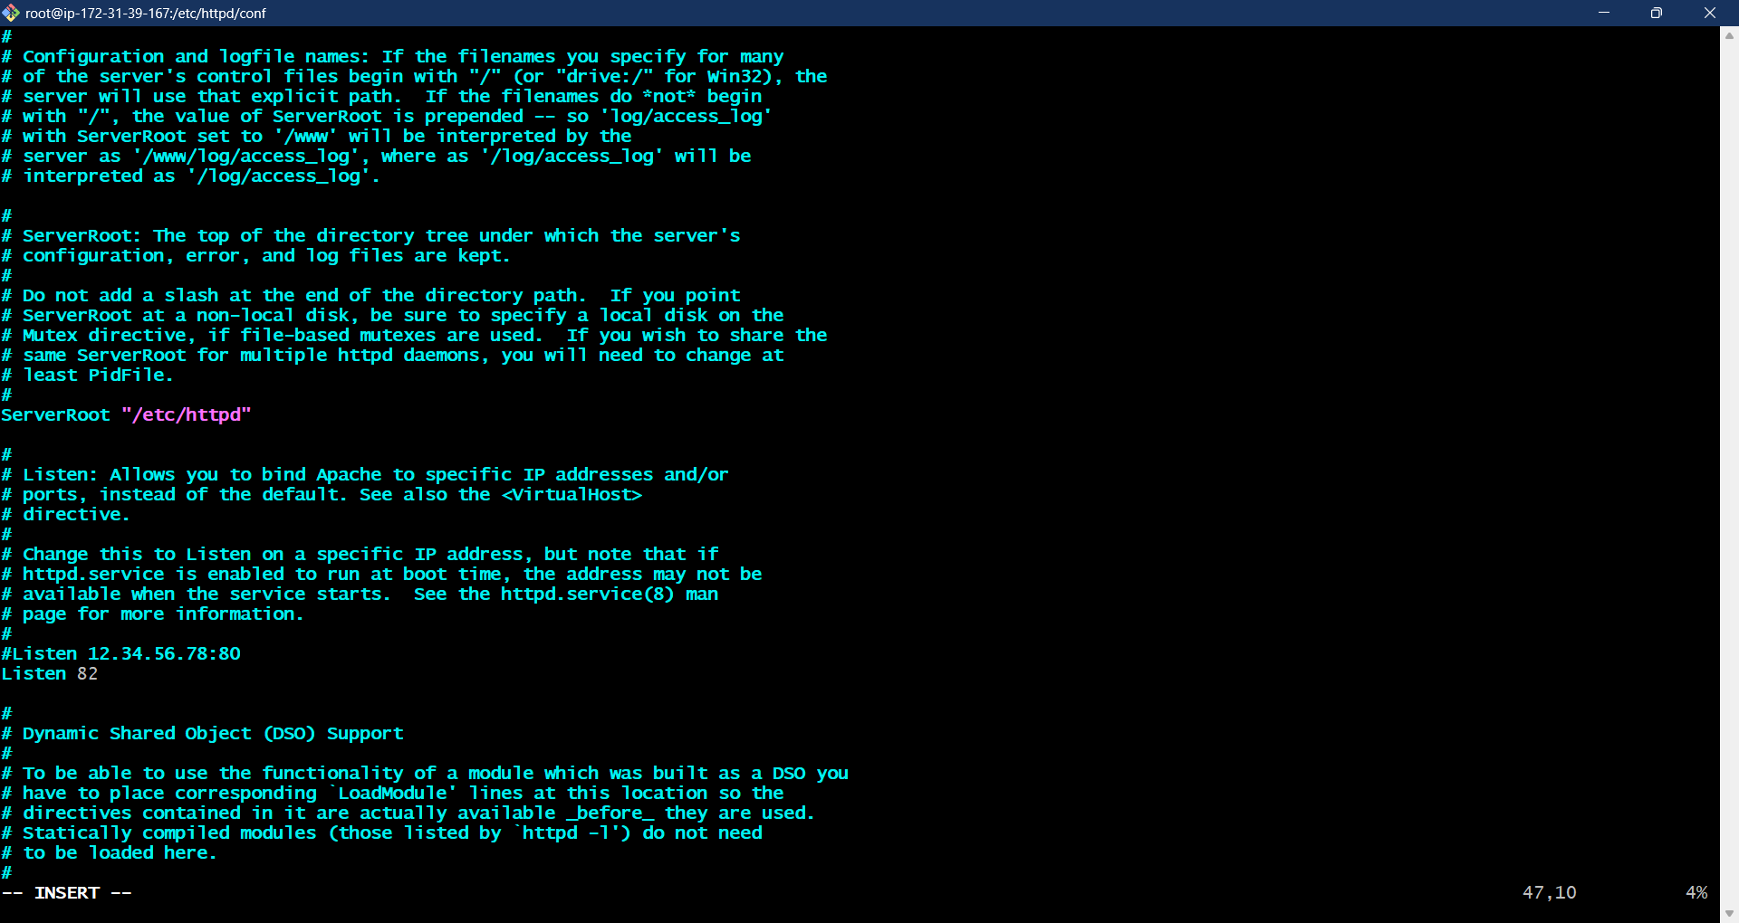

* After entering in to file look LISTEN 80 and the change 80 to 82 by using “i” command
* Save it by entering esc button :wq!
* Run command : systemctl restart httpd

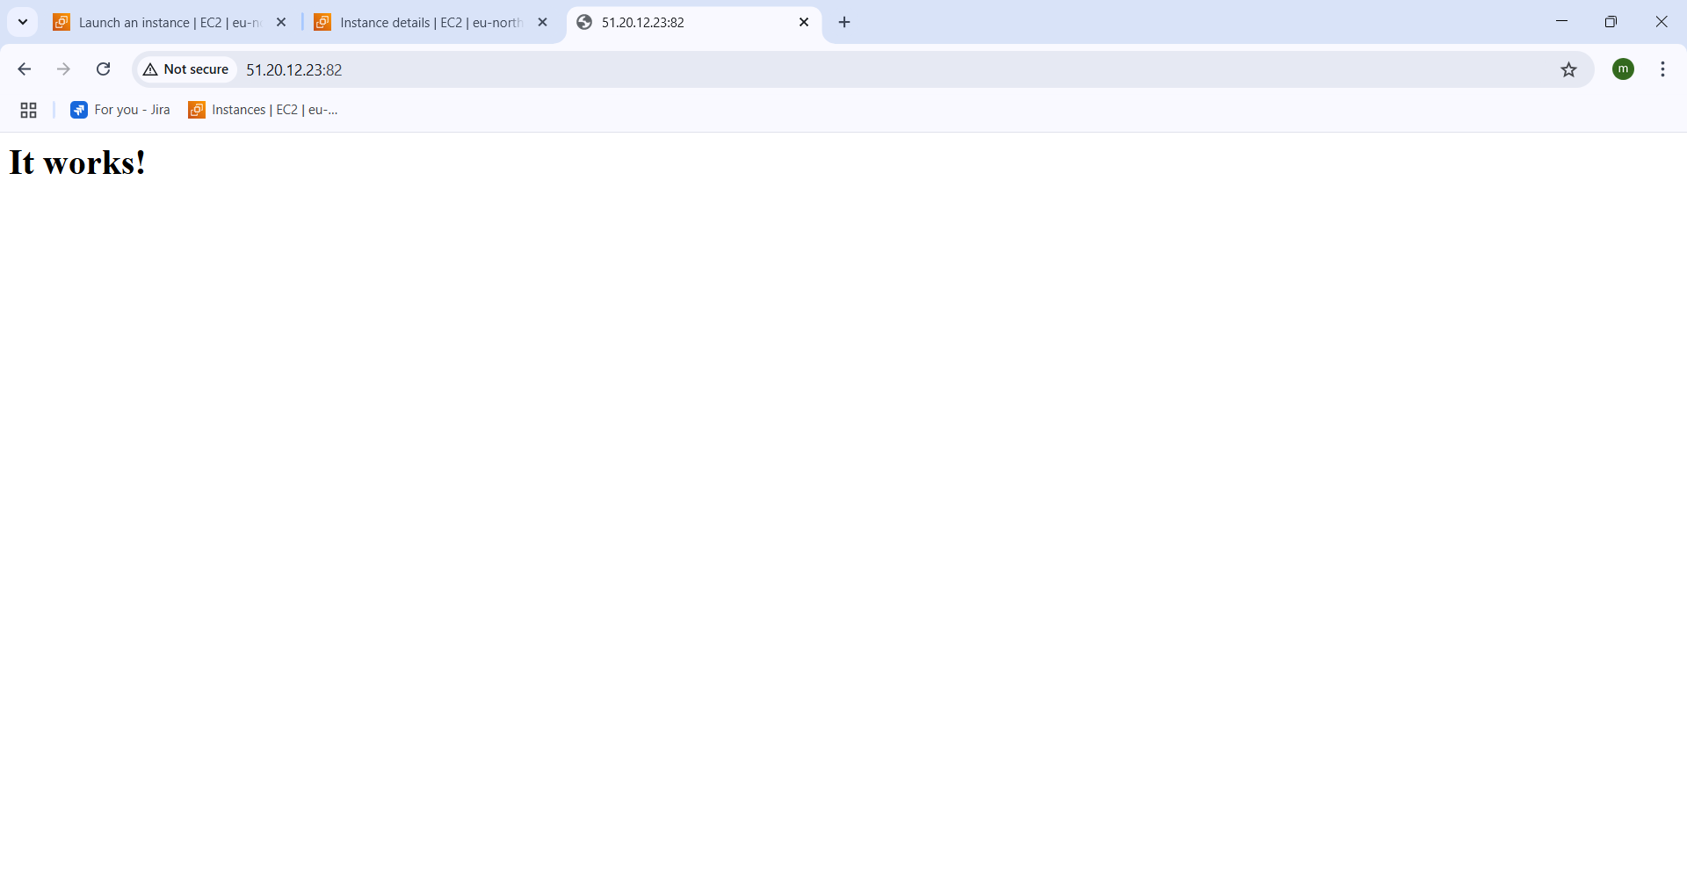

* Copy the ipv4 adress and enter : “ipv4 public address” :82
* You can see the the httpd is running on port 82.

**Deploying sample index.html on httpd:**

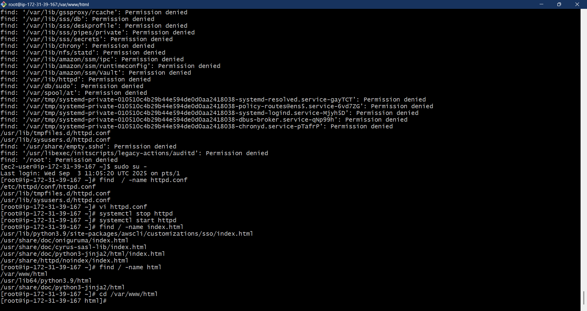

* Go to the html directory where the index.html file is present
* Cd /var/www/html



* Enter : vi index.html – to vie the file contents

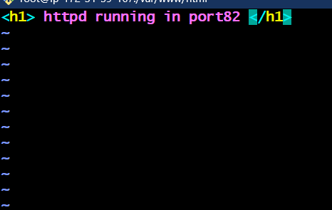

* In the file enter the out put you want
* And save it by entering esc button :wq!



* Systemctl restart httpd

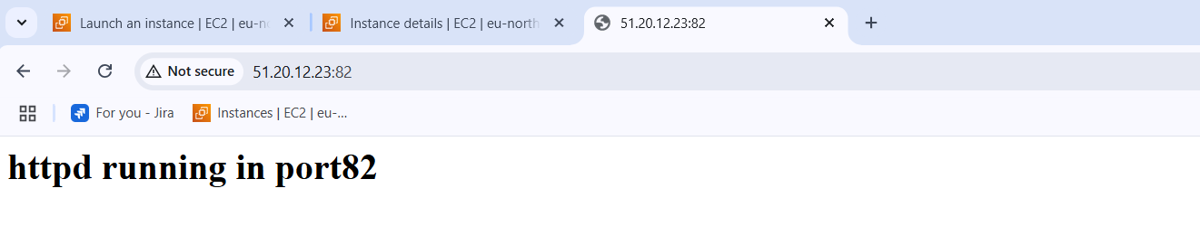

* ENTER : AWS ipv4 adress and enter port : “ipv4 public address” :82
* You can see the page with the index.html I have provided.